Grade 4

Waves and Information

Experience 2

What are the properties of waves?
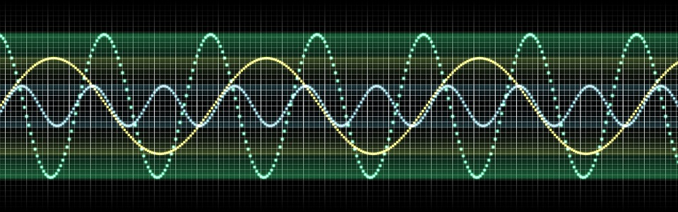

Wave Properties
Read the information below.
A wave is a regular pattern of motion up and down or side to side. A wave is initiated (caused) by a disturbance or vibration. The vibration allows the energy it creates to be transferred through the wave in a predictable wavelike (up and down or side to side) pattern. If more energy is added to the wave it moves faster or higher, if energy is taken away the wave moves slower or lower.

Use the site listed here for “phet colorade”. It is a site that allows you to create waves and manipulate the waves. https://phet.colorado.edu/en/simulation/wave-on-a-string
- Click on rulers (bottom left) – the rulers can be moved by dragging them. Put the “1 cm mark where the green dot starts in the wrench on the wave.
- Click on Oscillate (top right)
- Click on either “normal” or “slow motion” (center bottom)
- Watch the wave.
- Change the settings and see what happens.

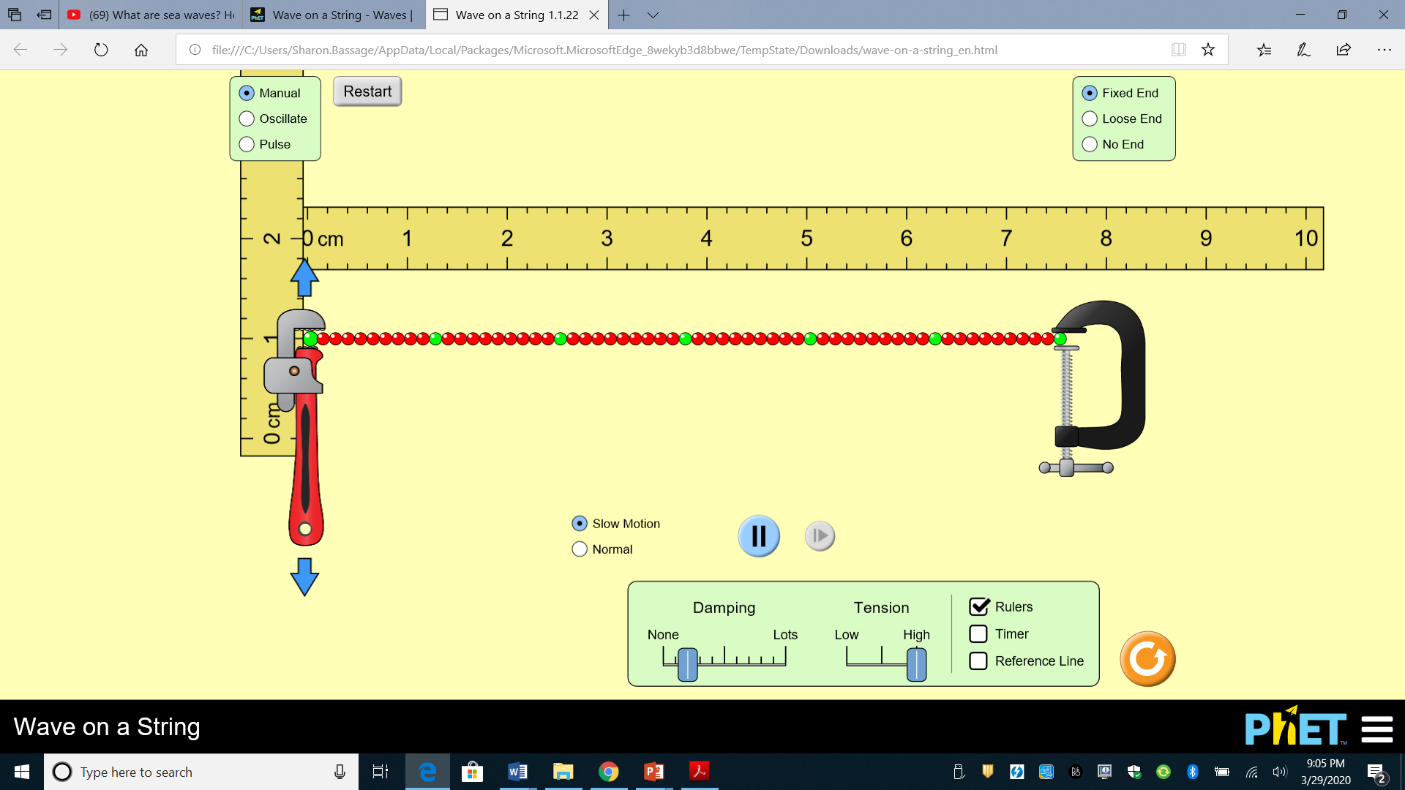

After working with the wave answer the following questions.

- How did you change the height of the wave? ________________________________

_____________________________________________________________________

- If you adjust the amplitude to 0.5 cm how high does the top of the wave go? How low does the bottom of the wave go? Hint: click on the slow motion or stop the wave using the blue double black line to observe this better. _____________________________

- Adjust the amplitude to 1.0 cm. How high does the top of the wave go? How low does the bottom of the wave go? ______________________________________________

- What pattern do you see with the high and low part of the wave? ________________

_____________________________________________________________________

- What happened when you changed the frequency of the wave? _________________

_____________________________________________________________________

- Adjust the frequency to 2.0 Hz (hertz). What do you notice about the wave? _______

_____________________________________________________________________

A wavelength is the measure of distance from one part of a wave to the same spot on the next wave. For example the distance from the top of one wave (crest) to the top of the next wave or from the bottom of one wave (trough) to the bottom of the next wave.
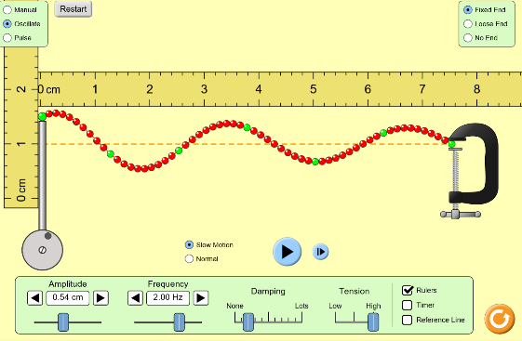
- At 2Hz how many wavelengths is there. Hint: stop the wave using the blue double line/arrow button when the green dot is at the highest point. Count from the top of one wave to the top of the next etc..

__________________________________________

- At 2 Hz how long is the wavelength? (measure from the top of one wave to the same spot on the next) ___________________________

- Adjust the frequency to 3.0 Hz. How many wavelengths are there now? __________

- At 3.0 Hz what is the length of the wavelength? _____________________________
Continue on to this weebly site: https://clarkscience8.weebly.com/properties-of-waves.html

Read through the information on the site.

Watch the videos.

Draw a wave on the line below. Add the following vocabulary and features to the wave.

wave amplitude crest trough wavelength
4 3 2 1 0 1 2 3 4

